Analysis and Discussion
Analysis
Results are from a 101-trial Optuna search over spiking-specific and architectural hyperparameters of a spiking EEGNet, evaluated under nested leave-one-subject-out (LOSO) cross-validation on BCI Competition IV 2a (4-class motor imagery), with the remainder of the EEGNet structure held fixed.
Generalization performance
The best configuration reached 49.2% mean balanced accuracy across the nine held-out subjects (chance = 25%; search mean 44.9%, median 45.8%), only 3.5% above the median trial. Per-subject accuracy ranged from 34.0% to 63.0% (Fig. 1), and this variance was driven by subject identity rather than class identity: Subject 5 (34.0% mean balanced accuracy) scored 7% on tongue prediction while near-average elsewhere, whereas Subject 8 (61.6% overall) exceeded 80% on right-hand and tongue (Fig. 2).
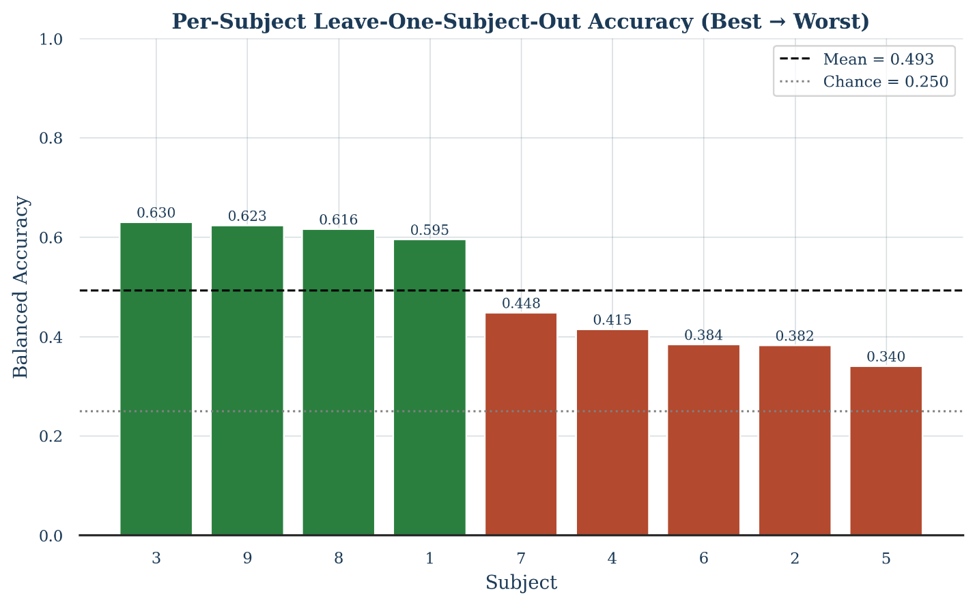
Bar chart of the nine held-out subjects’ balanced accuracy sorted highest to lowest, with reference lines for the group mean (49.3%) and chance (25.0%). Every subject decodes well above chance (34.0% to 63.0%), but the spread shows generalization is highly uneven across subjects.

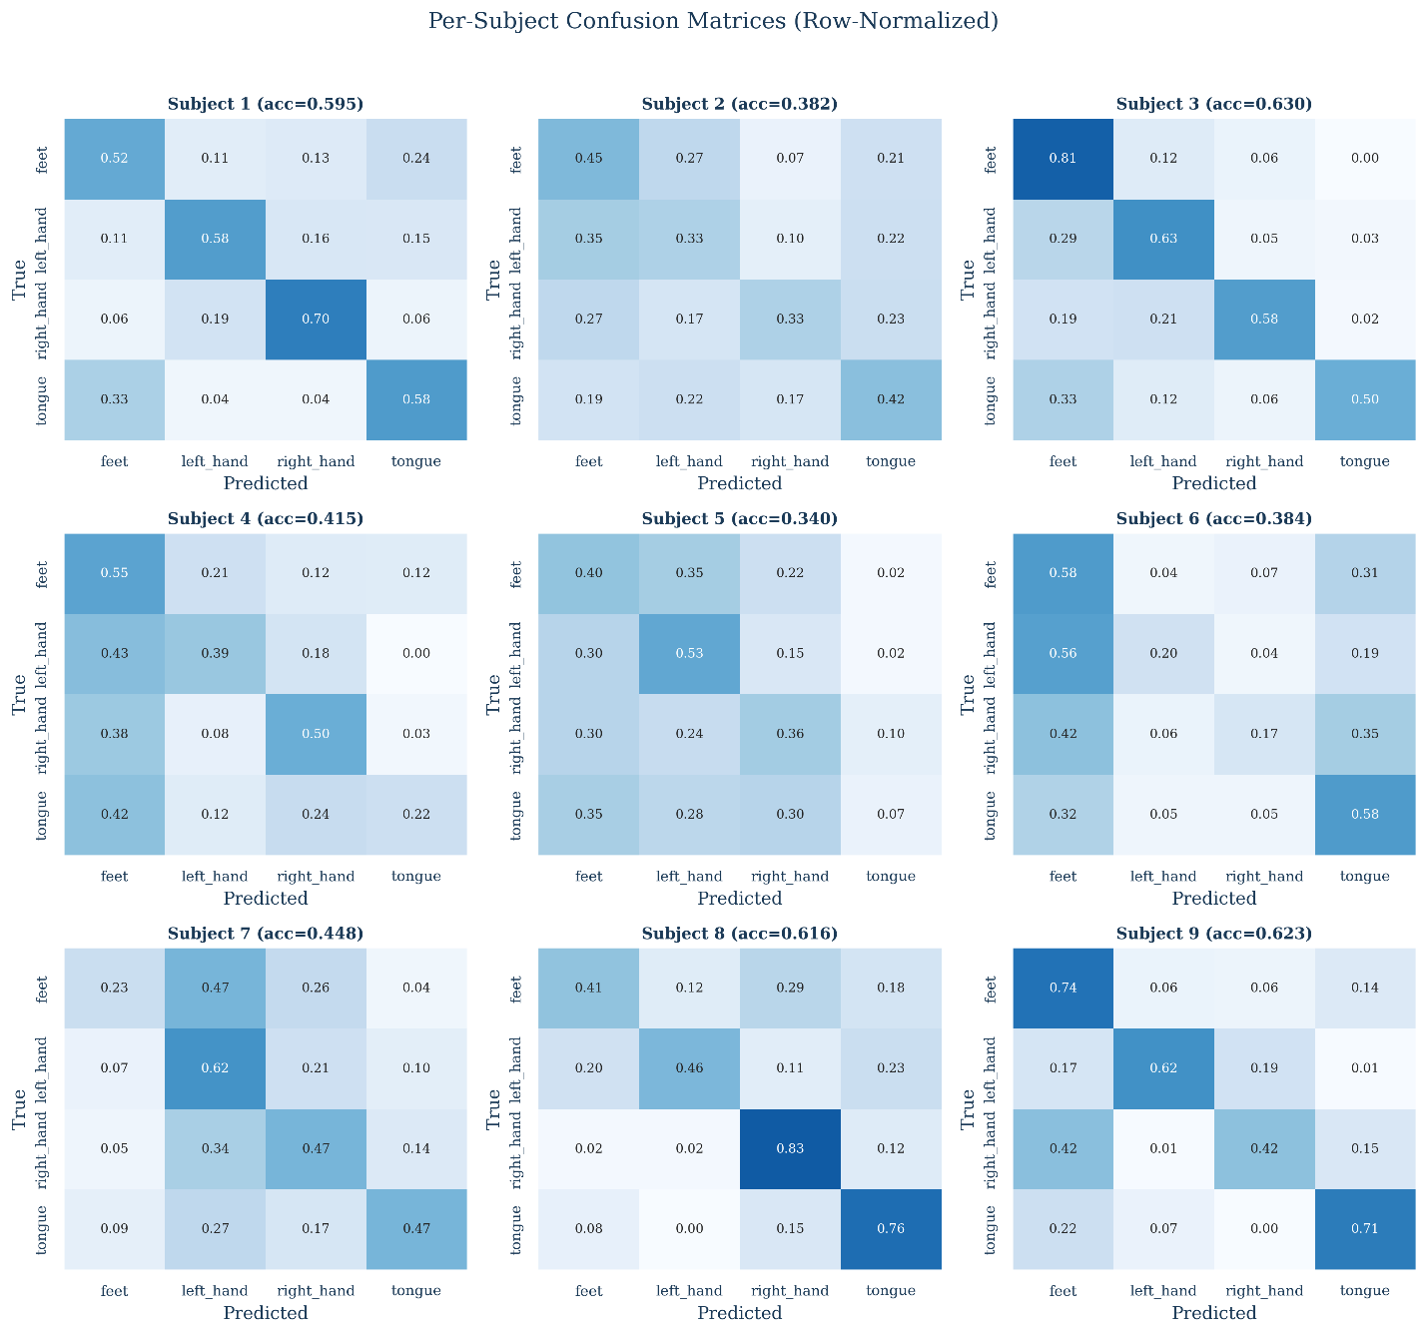
Heatmap of balanced accuracy per class (feet, left hand, right hand, tongue). Failures are subject-specific, not class-specific (e.g., Subject 5 collapses only on tongue), indicating cross-subject calibration failure rather than a class-level weakness.
Search behavior and predictors of performance
The mean balanced accuracy distribution was left-skewed, with a tail of poor trials down to 31.0% and a dense cluster between 44% to 49%. Nearly all improvement occurred in the first 11 trials, with smaller improvements afterwards. Pearson correlation and Random Forest permutation importance agree that the number of temporal filters (r=0.49) and separable kernel size (r=0.46) are the strongest predictors, with bandpass frequency low (r=-0.36) and dropout (r=-0.33) as the strongest negative predictors (Table 1). Learning rate exponent is the exception as it has negligible linear correlation (r=-0.03) but by far the highest permutation importance (~0.52, Fig. 3), indicating a non-linear "sweet spot" invisible to linear analysis. Spiking-specific dynamics parameters (beta, spike gradient slope) show weak correlation and negligible importance.

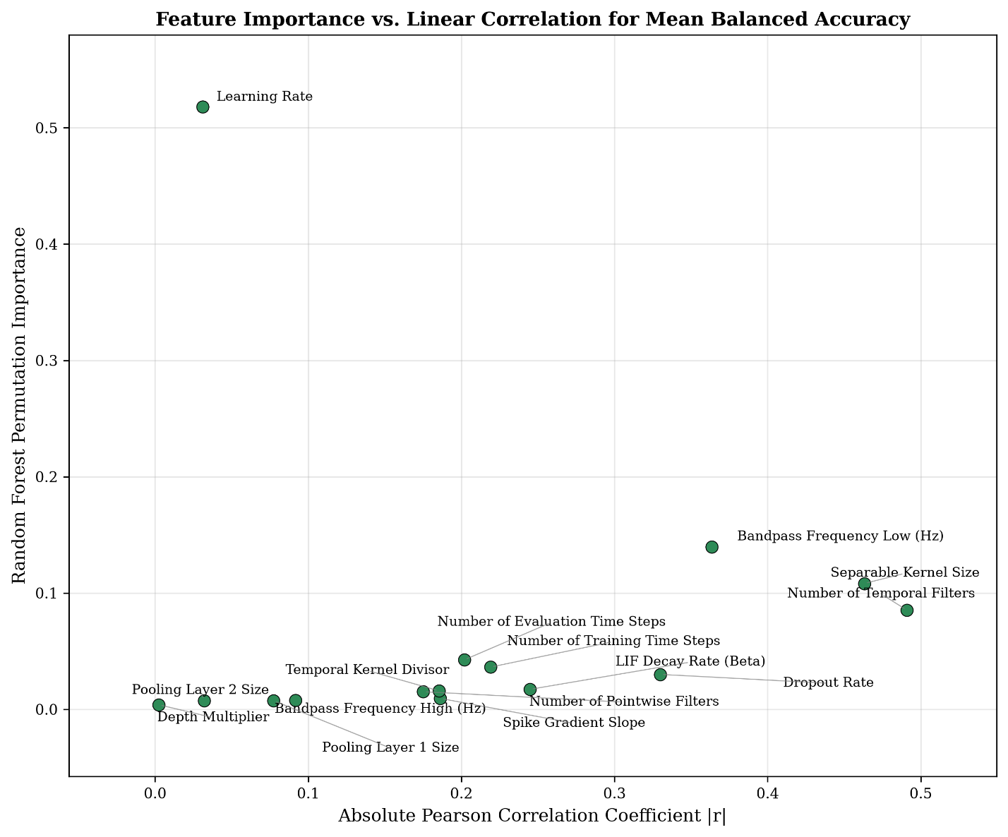Scatter of Random Forest permutation importance against absolute Pearson r for each hyperparameter. Learning rate sits far above the trend line with high importance despite near-zero correlation.
Top Hyperparameters by Permutation Importance and Linear Correlation
Hyperparameter | Pearson r | RF Importance
Learning Rate Exponent | -0.03 | 0.52
Bandpass Frequency Low (Hz) | -0.36 | 0.14
Separable Kernel Size | 0.46 | 0.11
Number of Temporal Filters | 0.49 | 0.09
Dropout Rate | -0.33 | 0.03
LIF Decay Rate (Beta) | 0.24 | 0.02
Capacity parameters (top four rows) show agreement between linear and nonlinear metrics; Learning Rate's effect is visible only under permutation importance.

Architectural divergence from EEGNet defaults
The best trial's architecture differs from EEGNet’s defaults in several ways (Table 2): temporal filters, depth multiplier, and pointwise filters are all larger, but not proportionally as shown in EEGNet’s paper, as EEGNet's scaling rule would predict 81 pointwise filters from these values versus the 32 selected. The first-layer kernel is shorter than EEGNet's while the separable-block kernel is longer. Pooling aggressiveness is also inverted as pool 1 is larger than default and pool 2 is smaller, the reverse of EEGNet. Dropout (0.156) is below both of EEGNet’s defaults (0.25, 0.5).
Best Trial Hyperparameters vs. EEGNet Defaults
Parameter | Best Trial | EEGNet Default
Temporal Filters | 27 | 8
Depth Multiplier | 3 | 2
Pointwise Filters | 32 | 16
Temporal Kernel Divisor | 7 | 2
Separable Kernel Size | 29 | 16
Pool 1 / Pool 2 Size | 5 / 6 | 4 / 8
Dropout Rate | 0.156 | 0.25 / 0.50
Readout Mode | Spike (Mean) | N/A
Every structural difference is directional -- a wide front end funneled through a narrow bottleneck, inverted kernel lengths, and inverted pooling -- rather than a uniform rescaling of EEGNet.
Readout mode and channel importance
Readout mode, which has no analog in the continuous EEGNet, affected accuracy directly. Spike (Mean) had the highest mean balanced accuracy (45.6%) and median (45.9%) and contained the top trials. Spike (Sum) followed (44.7%), and single-timestep readouts underperformed (Spike Last Step 44.6% and Membrane Last Step 43.1%, Fig. 4). An ablation from the best configuration corroborates this as switching to Spike (Last Step) or Spike (Sum) reduced accuracy to 46.5% and 44.1% respectively (Fig. 5). Removing the bandpass filter produced a higher point estimate 54.9% than baseline 49.3%. Occlusion-based channel importance was led by posterior/centro-parietal electrodes (POz, CP4, P1, CPz), each exceeding any strictly central sensorimotor channels (C3 ranked 5th, while C4 and Cz ranked 14th and 10th of 22 (Fig. 6)).

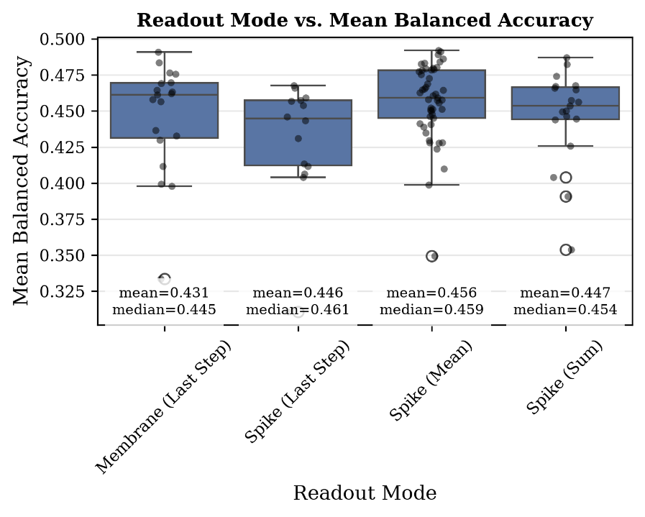
Box plot of balanced accuracy by Readout Mode (Membrane Last Step, Spike Last Step, Spike Mean, Spike Sum), trial points overlaid. Rate-coded readouts (Spike Mean, Spike Sum) outperform single-timestep readouts; Spike Mean shows the highest central tendency and tightest upper range.

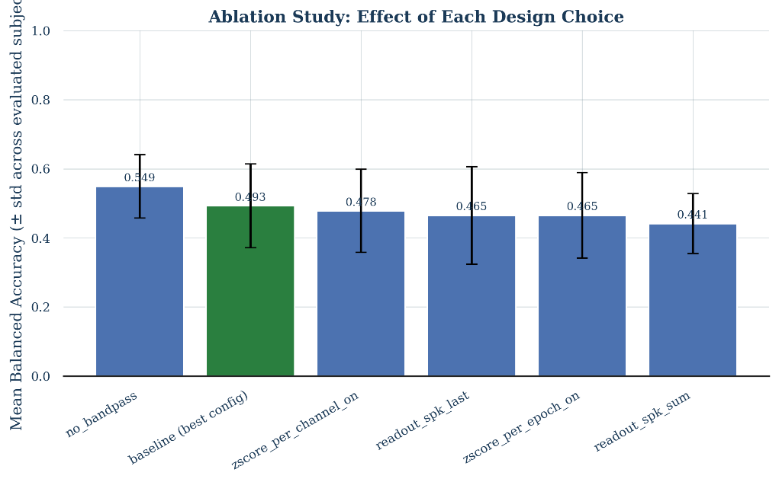
Bar chart of mean balanced accuracy (+/- std across subjects) for baseline and five single-change ablations. Both readout ablations reduce accuracy below baseline, corroborating Fig. 4; the bandpass-removal increase is within overlapping error bars and not a confirmed effect.

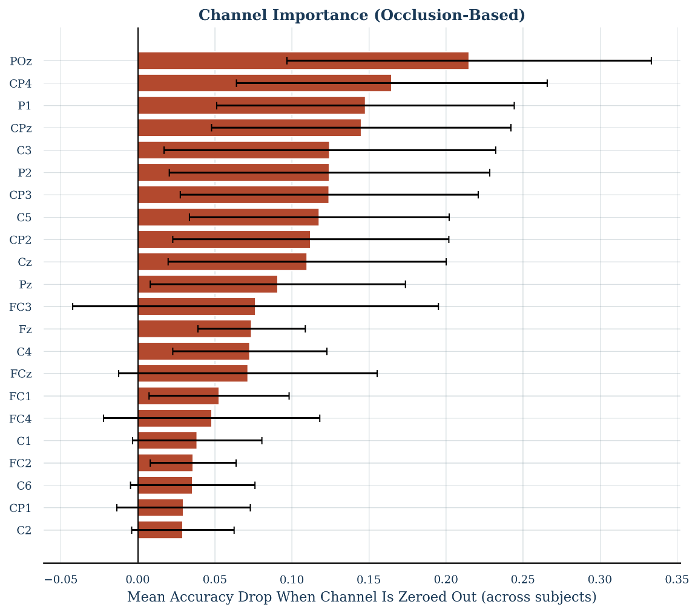
Ranked bar chart of mean accuracy drop when each channel is zeroed, averaged across nine subjects, with across-subject error bars. Decoding-relevant information concentrates in posterior/centro-parietal channels rather than the classical central sensorimotor strip.

Discussion
The biggest caveat to all interpretation presented here is that this work does not include a continuous EEGNet trained under the identical nested-LOSO protocol used here. The comparison to standard EEGNet is therefore made against its published defaults and against literature-typical accuracy levels (commonly 70-80%+), most of which use within-subject validation rather than nested LOSO. The observed accuracy gap thus reflects both the spiking conversion and the harder protocol, and the two cannot be separated without a matched baseline (see Limitations).
What translated well, and what did not
EEGNet's core mechanism, decoding via learned spatiotemporal filter capacity, appears to survive spiking conversion as temporal filters and separable kernel size dominate both correlation and importance rankings, while spike-specific dynamics (beta, gradient slope) contribute little. What did not transfer directly is how that architecture capacity is used. The inverted pooling sizes (EEGNet pools lightly after depthwise and aggressively before readout, whereas Spiking EEGNet does the opposite) and inverted kernel-length ordering (EEGNet uses one long kernel in the first layer and a fixed, shorter kernel later, whereas Spiking EEGNet does the opposite) are both explained by spiking representations carrying information in discrete, time-resolved events, so the network protects temporal resolution later in the network, unlike EEGNet's smooth continuous activations.
Learning rate sensitivity and readout design
Learning rate's dominant nonlinear importance despite near-zero linear correlation shows a narrow optimum where values on either side hurt accuracy, which a linear fit averages to near-zero slope. This may reflect the added sensitivity of training through a surrogate gradient rather than a true derivative, implying that reusing an original model's training hyperparameters is unsafe once the activation function itself changes. Conversely, readout mode’s effect is more direct and visible. Due to a spiking network's output being a spike train rather than a single deterministic value, some mechanism must collapse it into a decision, and integrating over the full simulation window (Spike Mean) outperforms single-timestep readouts, plausibly by smoothing trial-to-trial spike-timing jitter. This is a design choice with no EEGNet analog.
Spatial reorganization and implications for CNN-to-SNN conversion
The model's preference for posterior/centro-parietal electrodes over the classical central sensorimotor channels may be a byproduct of the nested LOSO protocol itself. Because the model is never allowed to adapt to a given subject's individual sensorimotor layout, it may instead rely on spatial patterns that are more stable across subjects, even if those patterns are individually less informative. However, this explanation cannot be confirmed without testing a standard (non-spiking) EEGNet under the same LOSO protocol for comparison. Taken together, these results suggest that converting a CNN like EEGNet into a spiking network does not require rebuilding every component equally. Capacity-related parameters (e.g., number of filters, kernel size) appear to transfer reasonably well, needing only minor adjustment. Parameters governing how information is processed over time (e.g., pooling placement, dropout, readout mode) appear to require more substantial re-tuning, since they behave differently once the network encodes information as time-based spikes rather than continuous values. Finally, training parameters, particularly learning rate, likely require a fundamentally different tuning approach that can detect a narrow optimal range rather than one that assumes performance changes steadily as the parameter increases or decreases.
Limitations and future work
The central limitation is the absence of a continuous EEGNet trained under the identical protocol, without which the cost of spiking conversion cannot be separated from the cost of the harder evaluation protocol; this comparison is the most direct next experiment. A related limitation is computational as due to resource constraints each model in the search was trained for only 50 epochs, compared to the 300 epochs typically used for EEGNet. This shorter training budget may have disadvantaged the spiking network relative to its true potential and may partially confound comparisons with EEGNet's published results. The search also plateaued after Trial 63, suggesting that the 49.3% result reflects convergence within the current search space and training budget, rather than a hard ceiling on performance. Finally, the dropout and channel-reorganization interpretations are hypotheses motivated by, but not directly tested by, the present experiments, and all results derive from a single dataset and architecture family, limiting how far these conclusions can be generalized to other spiking-CNN conversions.

Current Problems and Next Steps
Current Study Problem | Solution
No EEGNet LOSO baseline for original or searched parameters | Run 2 baselines for EEGNet LOSO on the same data, one with parameters presented in the EEGNet paper and one with parameters searched by Optuna.
No bandpass filter currently shows a higher accuracy | Remove bandpass filter. This might also help Optuna find a better result due to 2-dimensions less in the search space.
Using less epochs than the original EEGNet study | Unsure how to fix this as when you set epochs higher than 100, some models will not train within the ARC Cluster 24 hour limit due to doing 9-fold evaluation.

Next Steps
- Remove bandpass filter from pipeline
- Rerun pipeline
- Run both EEGNet baseline model
- Write conference paper
- Submit paper

